1. What goes in the status column?
Based on the live data and the SOP, here's the recommended enum for LAPTOP_LABELING.status:
RECEIVED → REFURBISHMENT_STARTED → REFURBISHMENT_COMPLETE → QC_APPROVED → QC_FAILED → DISPATCHED → UNDER_REPAIR → RETIRED
The working column (Working / Not Working) gets retired — it's fully covered by UNDER_REPAIR and RETIRED above. Two statuses worth flagging: QC_FAILED needs to exist as a state (not just a note) because the SOP says the device loops back to Stage 2 and needs a full re-run. RETIRED captures the end-of-life decision (recycle / decommission) that currently has no home.

2. assigned_to — you're right, UserDetails is for beneficiaries
Yes, your read is correct. UserDetails is the beneficiary table — the person receiving the laptop. So the current assigned_to text field on LAPTOP_LABELING is likely pointing to a beneficiary, which means USER_DETAILS.id is the right FK target.
The distinction then becomes:
- allocated_ngo_id → FK to NGO table (which organisation the laptop is going to)
- assigned_user_id → FK to USER_DETAILS (the specific beneficiary within that NGO)
LAPTOP_USER_MAP already exists as a junction table for this exact relationship. The question is whether you need both — assigned_user_id on LAPTOP_LABELING AND LAPTOP_USER_MAP. The map table is better because it's historical (a laptop could be reassigned). assigned_user_id as a direct column would only ever hold the current person. My recommendation: keep LAPTOP_USER_MAP as the source of truth, drop the assigned_to text column, and let the app query the map for current assignment.

3. actor_role and verifier_role in STAGE_DEFINITION
These are role labels, not user accounts. Think of them as job titles that define who is allowed to perform and approve each stage.
actor_role = the person doing the work. verifier_role = the person signing it off.
For your 6 stages:
Stage | actor_role | verifier_role
1 — Received | Intake Staff | Intake Supervisor
2 — Refurbishment | Refurbisher | QC Technician
3 — QC Check | QC Technician | QC Supervisor
4 — Distribution | Dispatch Coordinator | Dispatch Supervisor
5 — Post-deployment | Programme Coordinator | Programme Manager
6 — Monthly monitoring | Programme Coordinator | Programme Manager
The requires_different_actor flag on Stage 3 is the machine-enforceable version of this — the system checks that LAPTOP_STAGE_RUN.started_by (who did Stage 2) is not the same person as LAPTOP_STAGE_RUN.verifier_name (who is approving Stage 3). The roles table tells you what titles are allowed; the flag tells you when the same person is explicitly forbidden.

4. The gating mechanism — let's discuss
The core idea is: before a laptop can move from Stage N to Stage N+1, the system checks a set of rules and refuses the transition if any blocker fails. Here's how the tables work together:
STAGE_GATE_RULE (the rules, defined once)
rule_id | stage_id | rule_description | blocks_progression
--------|----------|--------------------------------|-------------------
1 | 1 | All photos uploaded | true
2 | 1 | Serial number verified | true
3 | 3 | QC by different person than S2 | true

STAGE_GATE_EVALUATION (evaluated per laptop per run)
eval_id | run_id | rule_id | passed | failure_note
--------|--------|---------|--------|-------------
101 | 55 | 1 | true | null
102 | 55 | 2 | false | "Serial unreadable, escalated"
The flow when a technician tries to mark a stage complete:
- App looks up all STAGE_GATE_RULE rows for the current stage where blocks_progression = true
- Checks each one — some are automatic (e.g. "are all checklist items responded to?"), some require a human assertion
- Writes a STAGE_GATE_EVALUATION row per rule with passed = true/false
- If any row has passed = false → transition is blocked, status stays as-is, failure notes surface to the user
- Only when all blocking rules pass does the LAPTOP_STAGE_RUN get run_status = COMPLETE and the laptop status advances
The question worth deciding now is: who evaluates the gates — the app or a person?
Some gates are auto-checkable (has the checklist response table been fully populated? does started_by ≠ verifier_name?). Others need a human to assert (was the BIOS password set?). The cleanest approach is a mixed model — the app auto-fails any gate it can check programmatically, and for human-assertion gates the checklist item itself carries the gate (is_blocking = true on CHECKLIST_ITEM), so if that item's response isn't PASS, the gate evaluation fails automatically.
Starting with the data model — how all the gating tables connect and what each row means at runtime.
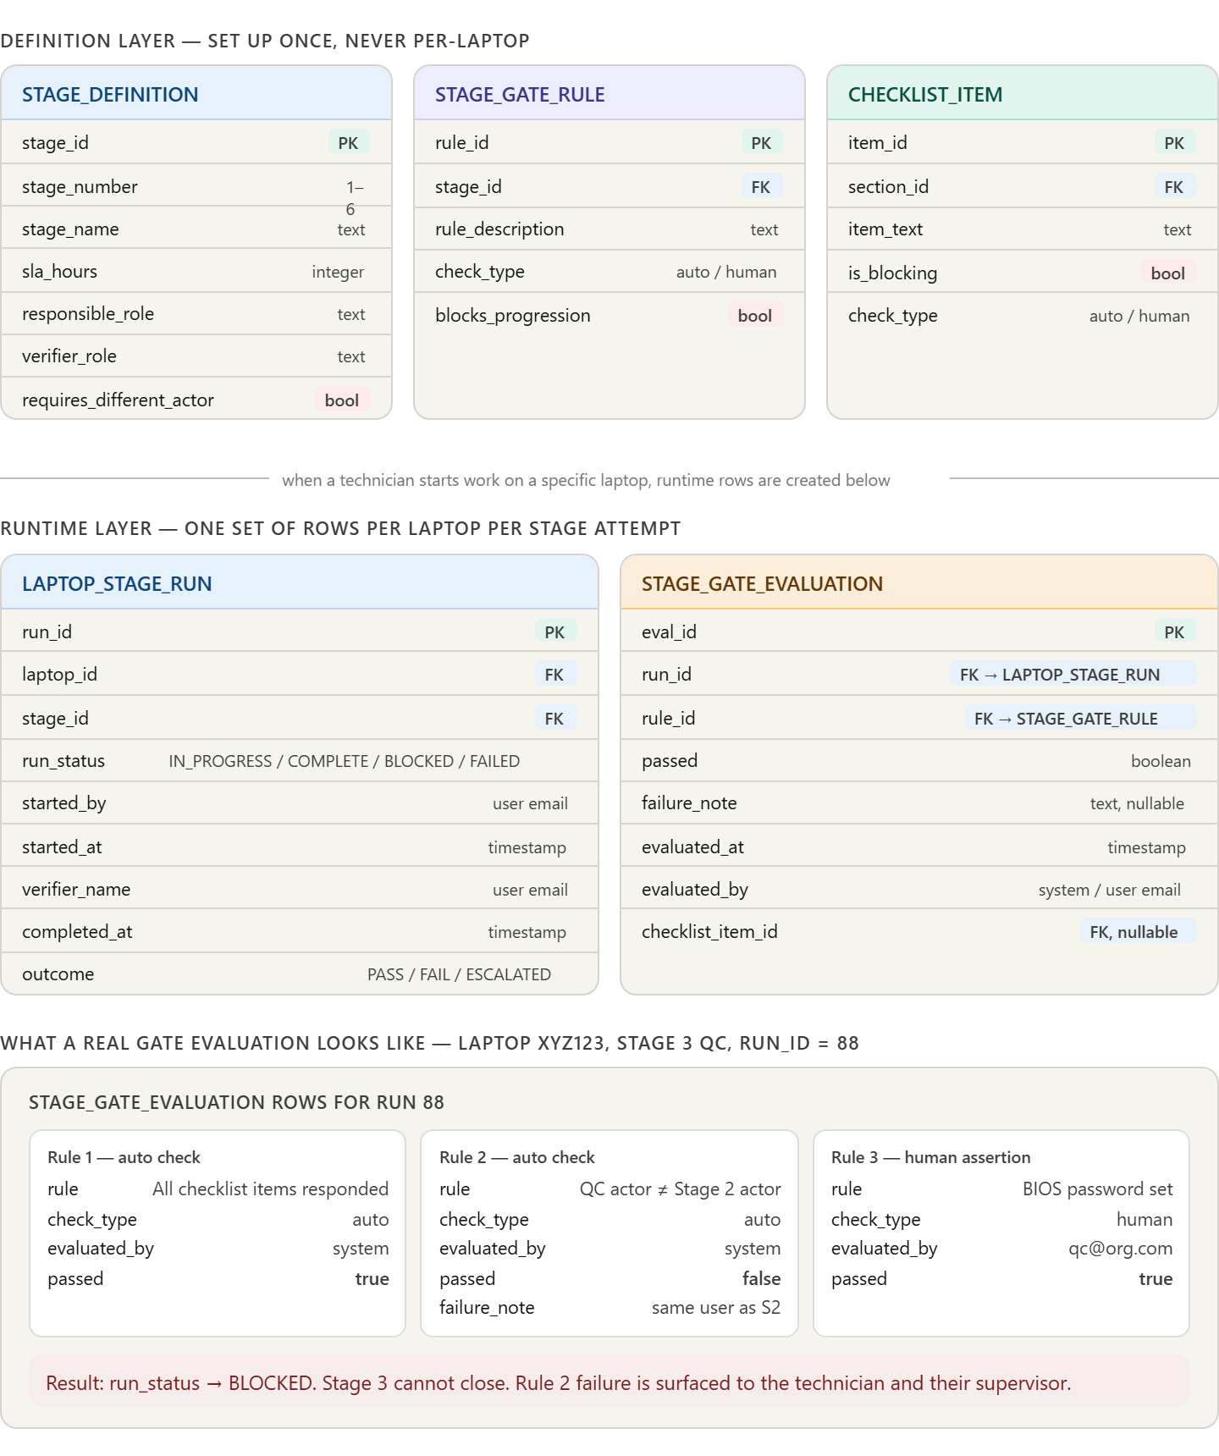
visualize show_widget
The key insight in that model: check_type on both STAGE_GATE_RULE and CHECKLIST_ITEM tells the system whether it can evaluate a rule itself (auto) or whether a human must assert it (human). Auto checks never need a UI — they run in the background when the technician hits "complete stage". Human-assertion gates surface as explicit yes/no questions before the stage closes.
Now the application logic — exactly what happens step by step when a technician tries to advance a laptop from one stage to the next.
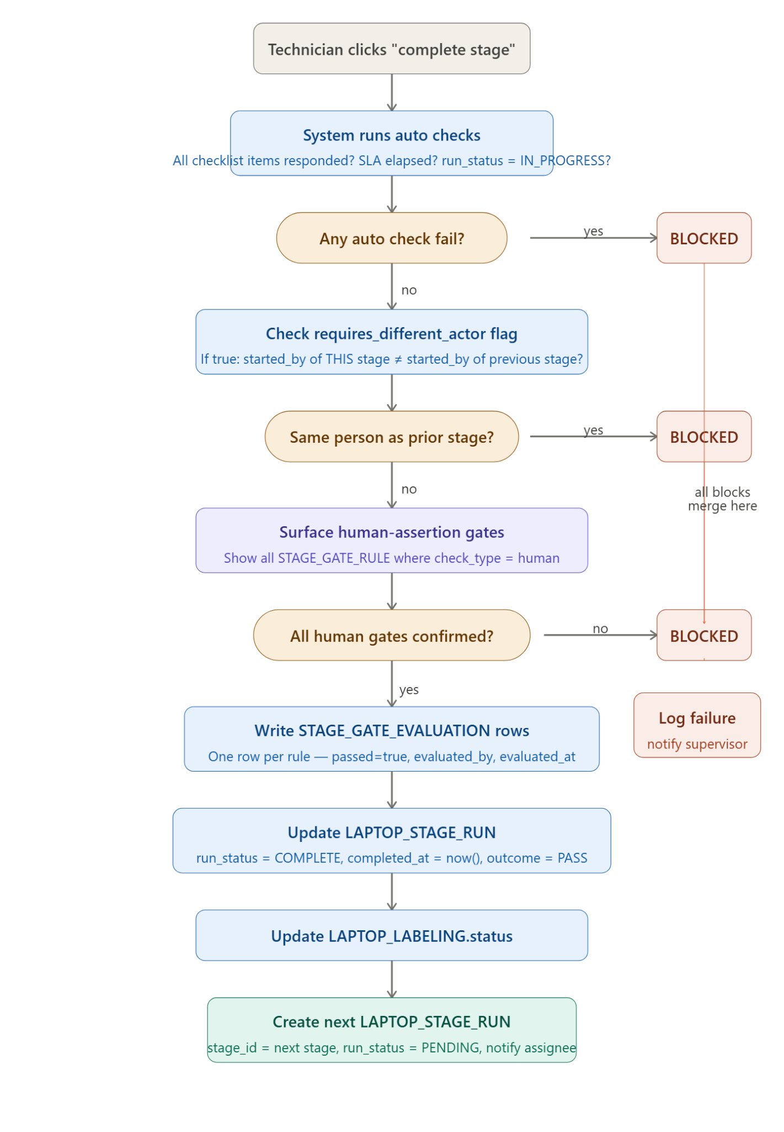
Every box in that diagram is clickable if you want to explore any step further. Now the third part — what happens when a gate fails and needs a re-run, which is the most operationally complex piece.
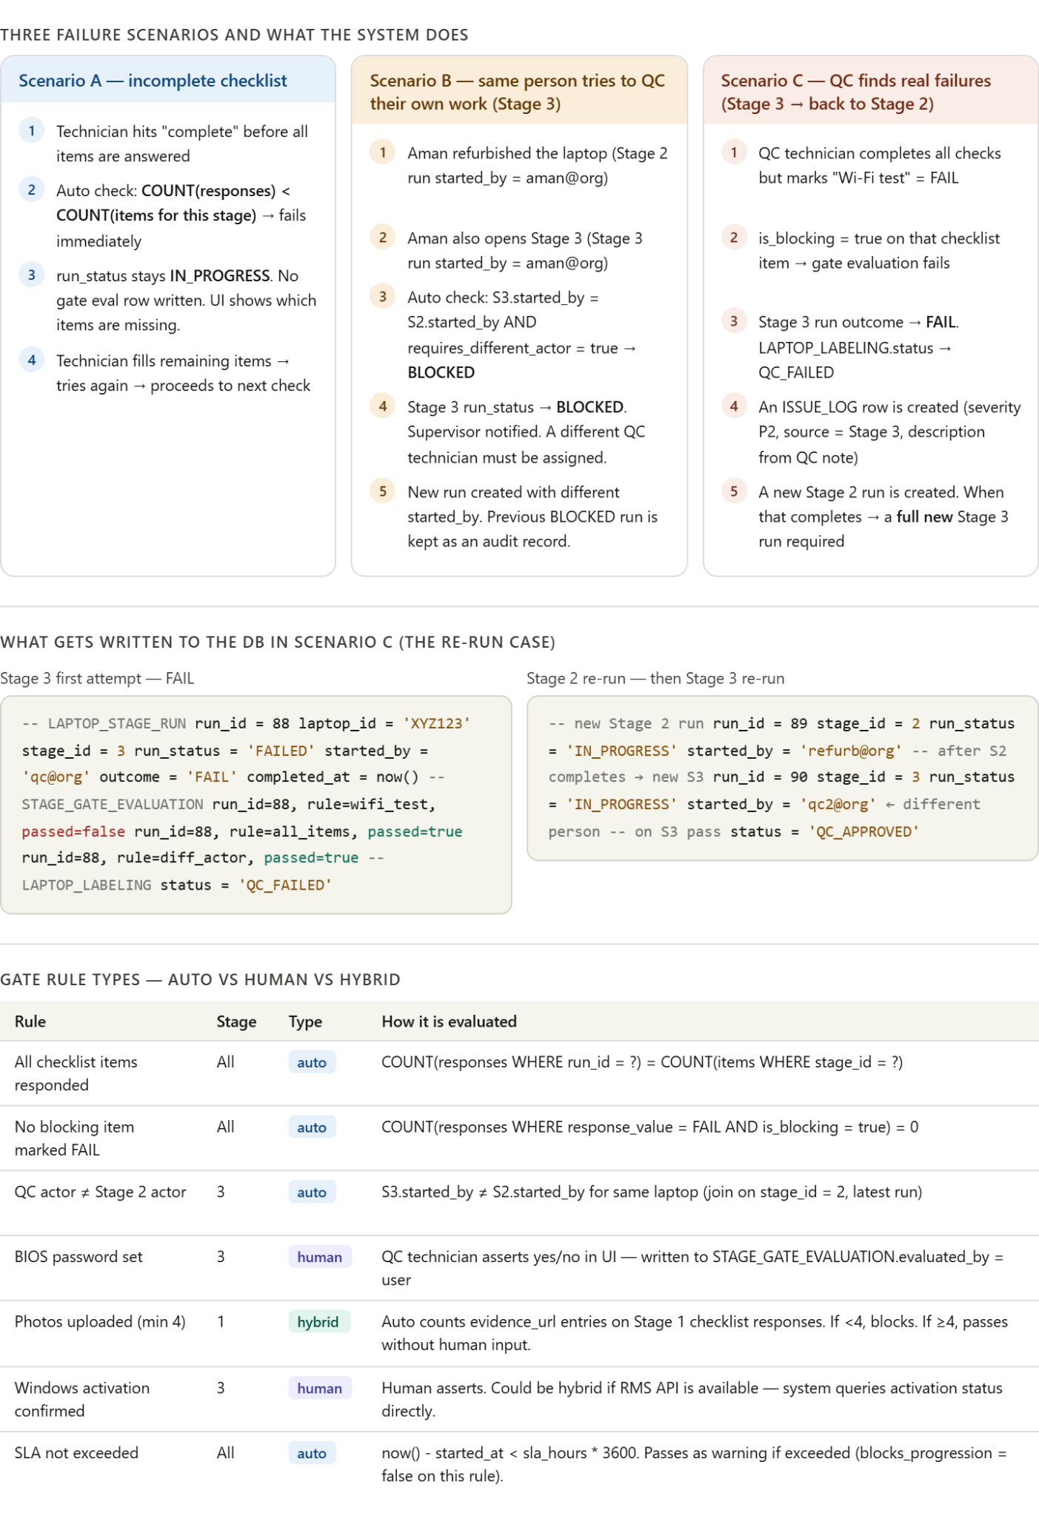
The thing that ties all three together is a single design decision worth pinning down now: run_status must never be deleted or overwritten — only new runs are created. When Stage 3 fails and goes back to Stage 2, you get runs 88 (S3-FAIL), 89 (S2-IN_PROGRESS), 90 (S3-IN_PROGRESS). The full history is queryable — you can see that laptop XYZ123 failed QC once, went back for rework, and passed on the second attempt. That's your quality audit trail.
A few practical decisions you'll need to make before implementing:
Who triggers the next stage run? Either the application creates it automatically when the prior stage closes (simpler, but the next assignee gets notified immediately), or a supervisor manually assigns the next stage (more control, but needs a queue/assignment UI).
Partial saves for human gates — should a technician be able to save their assertions mid-way and come back? The cleanest answer is yes: write STAGE_GATE_EVALUATION rows as the technician answers them, with passed nullable until submitted. Only the final submission triggers the full blocking evaluation.
SLA as warning vs hard block — from the SOP, SLA overruns don't actually prevent a stage completing, they just escalate. So blocks_progression = false on SLA rules, with a separate escalation trigger that fires when sla_hours is breached. This means SLA data is captured but doesn't jam the workflow.

